Revisions to

Allegheny County Health Department
Rules and Regulations
Article XXI, Air Pollution Control

(Tracking No. 105)

_______________________________

§2105.62, “Asbestos Abatement Applicability, Federal Requirements, Notices, and Permits”

and

§2109.07, “Penalties, Fines, and Interest”

{Document Date: December 8, 2025}

Tracking No. 105

TABLE OF CONTENTS

1. Changes to Article XXI Rules and Regulations:

§2105.62, “Asbestos Abatement Applicability, Federal Requirements, Notices, and Permits”
§2109.07, “Penalties, Fines, and Interest”

2. Technical Support Document

3. Documentation of Public Hearing and Certifications

Public Hearing Notice
Letters of Notification to PA DEP and U.S. EPA
Proof of Publication of Hearing Notice
Certification of Hearing
Summary of Comments and Responses
Certification of Approval and Adoption (Later)

- Proposed Regulation Revision

Deletions are shown with strikethroughs.
Additions are shown in larger font, bolded, and underlined.

****
§2105.62 ASBESTOS ABATEMENT APPLICABILITY, FEDERAL
REQUIREMENTS, NOTICES, AND PERMITS {Paragraph h amended July 16, 2009, effective July 26, 2009. Subsection h amended September 15, 2021, effective September 25, 2021. Subsection f and g amended November 24, 2025, effective December 4, 2025.}
****
f. Demolition Notice. No person shall demolish, or allow the demolition, of any facility unless the owner of the facility proposed to be demolished has either:

1. Submitted to the Department, and the Department has received, by no later than 10 days prior to the beginning of the proposed demolition, if there is:

- Less than 260 linear feet of pipe with ACM and a total of less than 160 square feet of, or no, ACM present in the facility,

A written notice, with the appropriate fee under Paragraph H of this subsection, which includes, at a minimum, the following information about the facility proposed to be demolished:

A. Names, mailing and street addresses, telephone numbers, and contact persons of the owner, and operator if not the owner, of the facility;

B. Name, mailing and street addresses, telephone number, and contact person of the person (e.g. contractor) to perform the demolition;

C. Exact location (e.g. street name and number) of the facility;

D. The age and prior and present usage of the facility;

E. Name, mailing and street addresses, telephone number, and contact person of the inspector, certified under §2105.61.a of this Article, who performed the ACM inspection at the facility proposed to be demolished;

F. Copy of the documentation of the ACM Inspector's certification under §2105.61.a and
Subparagraph 2.E of this Subsection; and

G. Copy of the documentation of the results of the ACM inspection showing that no asbestos removal project permit is required prior to demolition due to the absence, or the presence of less than 260 linear feet of pipe with ACM and a total of less than 160 square feet, of ACM in the facility; or

H. Demolition Notice Fees. For each demolition notice required under this section, the applicant shall submit to the Department a Demolition Notice Fee payable to the Allegheny County Air Pollution Control Fund, in an amount to be set by the Board of Health. Any fees approved by the Board of Health under the terms of this section shall not become effective until approved by the Allegheny County Council.
****

g. Undersized Project Notice. No person shall conduct, or allow to be conducted, the removal, encasement, or encapsulation of ACM on less than 260 linear feet of pipe and a total of less than 160 square feet of ACM at any facility, unless the owner of the facility has submitted to the Department a properly completed notice under this Section, with the appropriate fee under Paragraph 12 of this subsection, and such notice has been received by the Department either at least 10 days prior to the start of such proposed abatement project or, for a project involving less than seven (7) square feet of ACM, no later than 10 days after the completion of the project, or for a facility with a current Operating & Maintenance (O&M) Plan approved by the Department under this Subpart, as part of the appropriate O&M Plan quarterly report, and includes, at a minimum, the following information about the facility and the proposed abatement project or the completed project:

****
12. Undersized Project Notice Fees. For each notice required under this Section, the applicant shall submit to the Department an Undersized Project Notice Fee payable to the Allegheny County Air Pollution Control Fund, in an amount to be set by the Board of Health. Any fees approved by the Board of Health under the terms of this section shall not become effective until approved by Allegheny County Council.

****

§2109.06 CIVIL PROCEEDINGS {Paragraph a.1 amended September 6, 1995, effective October 20, 1995.}
****
b. Penalty Determination.

1. In determining the amount of the penalty, the Department shall consider: the wilfulness of the violation; the actual and potential harm to the public health, safety, and welfare; the damage to the air, soil, water, and other natural resources of the County and their uses; the economic benefit gained by such person by failing to comply with this Article; the deterrence of future violations; the costs of the Department; the size of the source or facility; the compliance history of the source; the nature, frequency, severity, and duration of the violation; the degree of cooperation in resolving the violation; the speed with which compliance is ultimately achieved; whether or not the violation was voluntarily reported; other factors unique to the owners, operators, or other responsible parties of the source or facility; and other relevant factors.
****

§2109.07 PENALTIES, FINES, AND INTEREST {Subsection b amended September 15, 2021, effective September 25, 2021. Subsections a and b amended November 24, 2025, effective December 4, 2025.}

- Fees. In the event a A source that fails to pay any fee required under this Article when due, the Department will compute a civil penalty shall pay a civil penalty of 50% of the fee amount, plus interest on the fee amount computed in accordance with Paragraph a.4 of §2109.06 of this Article from the date the fee was required to be paid. In addition, the source may have its permit revoked. The County will allow up to a fifteen (15) calendar day “grace period” from the due date of fees required under this Article prior to assessing the above referenced civil penalty and interest.

b. Disposition of Monies Collected.

1. All interest received by the County under this Article as a result of fees under Sections 2102.10.h, 2103.40.i, and 2103.41.a.1 of this Article shall be paid into the Allegheny County Air Quality Fund for the major operating permit program.

2. All interest received by the County under this Article as a result of fees, other than the fees under Sections 2102.10.h, 2103.40.i, and 2103.41.a.1 of this Article, shall be paid into the Allegheny County Air Pollution Control Fund.

3. Except as provided by Paragraph b.4 below, all All penalties, fines, interest, and other funds received by the County under this Article as a result of consent orders, noncompliance penalties, civil penalty actions, consent decrees, civil penalties, or summary proceedings, other than such funds provided for under paragraph 1 above, shall be paid into the Allegheny County Clean Air Fund.

4. Funds related to “costs of the Department” pursuant to §2109.06.b.1. for penalty determinations for major sources shall be paid into the Allegheny County Air Quality Fund; for all other sources, such funds shall be paid into the Allegheny County Air Pollution Control Fund.

End of Regulation Changes

2. Technical Support Document

Summary of Change

After evaluating the 2023 collected work metrics, data provided from both the Air Quality Enforcement and Permitting sections and an overall review of the 2023 and aspects of the 2024 budget, the Air Quality Program is proposing fee changes and supporting Article XXI amendments so that the Air Quality program, specifically both the Air Quality Fund (Title V fund) and the Air Pollution Control Fund (APCF) will remain supportive of a fully effective and staffed program.

Because the actual fee amounts are not included in Article XXI, the proposed fee changes will be presented to both the Board of Health and the Allegheny County Council for approval in documentation separate from this document. The proposed supporting Article XXI amendments are few and involve only two sections of Article XXI:

§2105.62, ‘Asbestos Abatement Applicability, Federal Requirements, Notices, and Permits,’ - language is proposed that will add a “Demolition Notice Fee” and an “Undersized Project Notice Fee;” and

§2109.07, ‘Penalties, Fines, and Interest,’ – language is proposed that will direct that funds related to “costs of the Department” pursuant to §2109.06.b.1. involving penalty determinations for major sources shall be paid into the Allegheny County Air Quality Fund, while for all other sources, such funds shall be paid into the Allegheny County Air Pollution Control Fund.

Impact on PA State Implementation Plan

The following Article XXI sections are being revised:

§2105.62, “Asbestos Abatement Applicability, Federal Requirements, Notices, and Permits”
§2109.07, “Penalties, Fines and Interest”

Neither section is part of the PA SIP. There is no impact on the SIP.

However, the change to §2109.07, “Penalties, Fines and Interest” will be submitted to U.S. EPA for consideration as a change to the Allegheny County Title V Partial Operating Permit Program.

3. Documentation of Public Hearing and Certification

Public Hearing Notice
Transmittal Letters to EPA and DEP
Proof of Publication of Notice of Hearing
Certification of Hearing
Summary of Comments and Responses
Certification of Approval and Adoption

NOTICE OF PUBLIC HEARING AND PUBLIC COMMENT PERIOD
FOR PROPOSED AMENDMENTS TO
ALLEGHENY COUNTY HEALTH DEPARTMENT RULES AND REGULATIONS
ARTICLE XXI, AIR POLLUTION CONTROL AND AIR QUALITY FEE SCHEDULES

The Allegheny County Board of Health will hold a public hearing on Monday, August 19, 2024, at 5:30 PM at the West Mifflin Borough Building, 1020 Lebanon Road, West Mifflin, PA, 15122 (please see the NOTE below regarding the hearing location) to take testimony on proposed modifications to the following sections of ACHD Article XXI, along with the corresponding sections of County Ordinance 16782:
- §2105.62, “Asbestos Abatement Applicability, Federal Requirements, Notices, and Permits” and related portions of §2101.20, “Definitions;” and
- §2109.07, “Penalties, Fines, and Interest.”
Testimony will also be taken on proposed modifications to the following fee tables:
- The Air Quality Program Fee Schedule; and
- The Air Quality Program Asbestos and Abrasive Blasting Fee Schedule.

NOTE: As of the posting of this notice in the July 18 Post Gazette, the location of the hearing stated above was not firm. However, the location stated above now is firm. The hearing will be held at the West Mifflin Borough Building.

The portion of the changes involving Article XXI §2109.07 will be submitted as a revision to Allegheny County’s Title V Partial Operating Permit Program as described in the associated Technical Support Document.

The proposed revisions to Article XXI and to the fee tables are available on the Allegheny County Health Department (ACHD) Air Quality web site at https://www.alleghenycounty.us/Services/Health-Department/Air-Quality/Air-Quality-Permitting/Public-Comment-Notices and https://www.alleghenycounty.us/Services/Health-Department/Air-Quality/Enforcement-Regulations-and-Compliance/Regulations-and-SIPs . Written copies may be obtained by calling 412-578-8115.

- Persons wishing to present testimony at the hearing must register by going to the ACHD’s Air Quality website at https://www.alleghenycounty.us/Services/Health-Department/Board-of-Health/Public-Hearing-Participation-Form. Persons who do not have access to the internet may register by calling 412-578-8115.
- You must register to present testimony no less than 24 hours in advance of the hearing.
- Testimony is limited to 3 minutes. Witnesses are requested to submit written copies of the testimony by email to aqcomments@alleghenycounty.us.

The Board will also accept written comments, beginning on Friday, July 19, 2024, and concluding at 11:59 PM on Monday, August 19, 2024, by mail to ACHD Air Program, 836 Fulton Street, Pittsburgh, PA 15233, or by email to aqcomments@alleghenycounty.us.

Please call 412-578-8115, if you have any questions or if you have any difficulty registering for the hearing.

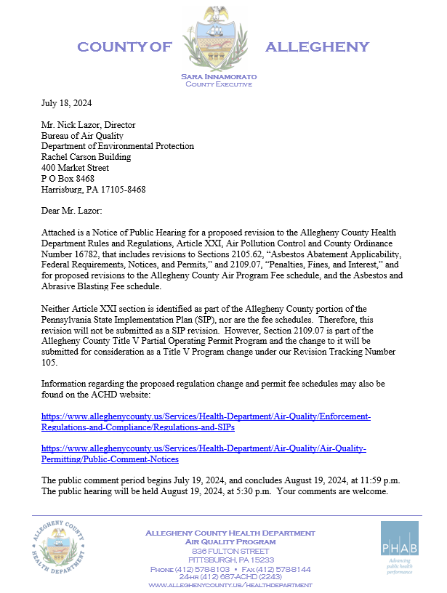

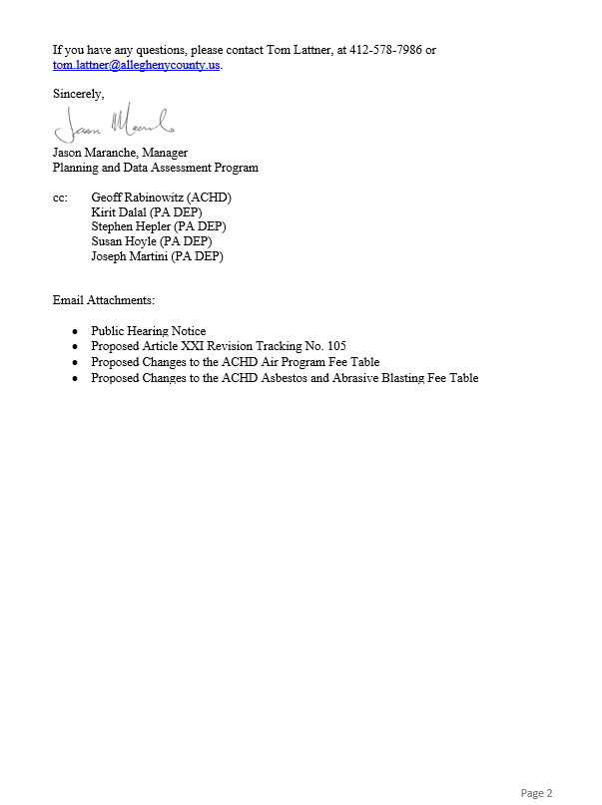

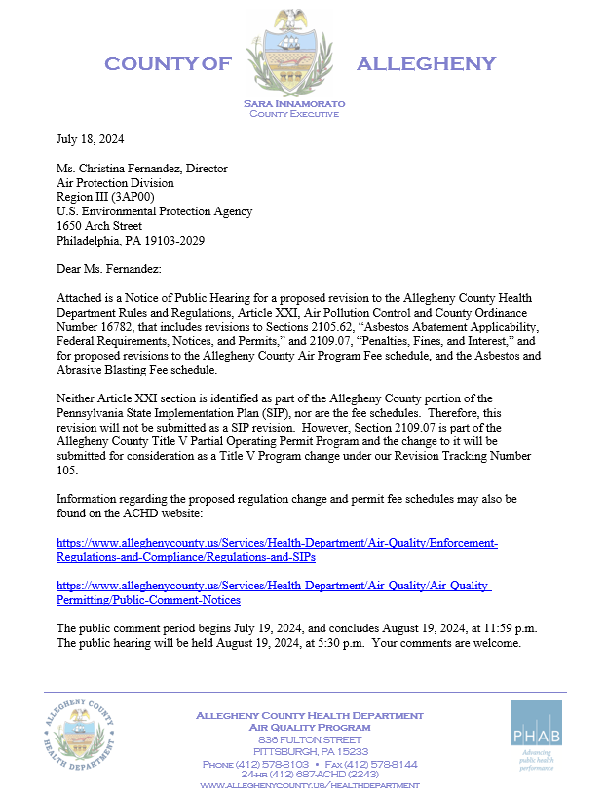

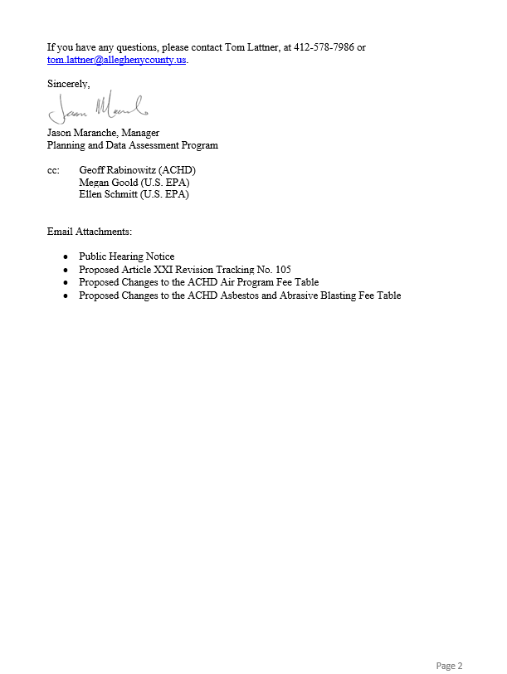

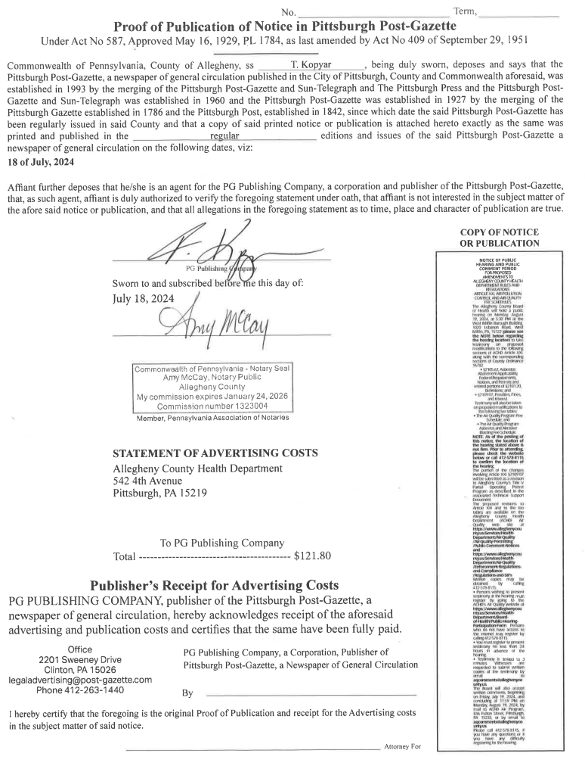

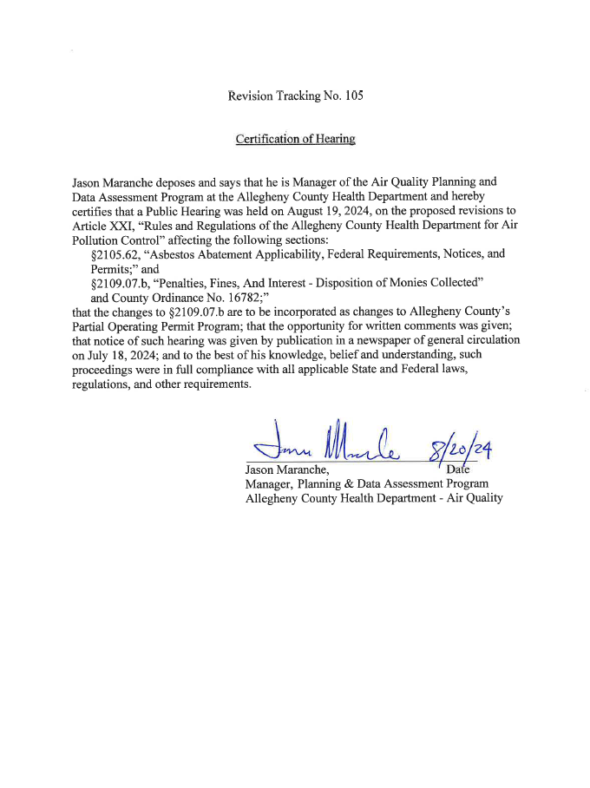

SUMMARY OF COMMENTS AND RESPONSES

Public Comment Period: July 19-August 19, 2024

# | Category | Comment | Response | Commenter(s)
1 | Support the Changes | We [residents and advocates] support the Allegheny County Health Department’s proposal to increase permit fees to fully fund the Air Quality Program and call upon all relevant authorities in the process to adopt the new fee structure. The program is currently severely underfunded, with a projected deficit of $1.8 million. Since 2019, the program has relied too heavily on the Clean Air Fund, receiving nearly $2.1 million for operating expenses. This program should be preserved for its primary purpose which is to support community projects that directly reduce pollution or educate residents about air issues and their health impacts. | The Department thanks you for your support of having a fully funded and fully staffed air quality program. | Commenters 1-150
2 | Support the Changes | It is necessary that the fees that ACHD charges facilities are sufficient to cover ACHD’s costs of administering both the Title V and non-Title V sides of its Air Quality Program. The costs of the program should be carried by the significant polluters seeking pollution. Permitting, monitoring, enforcement, and other duties can only occur if the Air Quality Program is fully funded. | The Department thanks you for your support of having a fully funded and fully staffed air quality program. | Commenters 151-153
3 | Support the Changes | EPA supports this ACHD action to ensure title V fee sufficiency for the ACHD Air program. EPA believes the increases in the fees as proposed in the notice will help to ensure ACHD continues to maintain the ability to successfully implement the Title V program as approved. The Clean Air Act (CAA) and the Code of Federal Regulations (40 CFR Part 70) stipulate that permit fees must be paid by sources to cover all reasonable (direct and indirect) costs required to develop and administer the permit program. Based on an EPA program evaluation of ACHD’s Title V program in 2017, it was found that revenues generated by emissions-based Title V fees were diminishing as a result of emissions reductions from stationary sources and that maintaining adequate permit program revenue to support current title V related expense would be an ever-increasing challenge. Title V revenues have been decreasing nationwide because of improved source performance, more restrictive emissions requirements, and source closures. | The Department thanks you for your support of having a fully funded and fully staffed air quality program. | Commenter 162
4 | Support the Changes | I [the Allegheny County Controller] submit this comment in favor of the adoption of the proposed fee schedule as it relates to the Air Quality Program. Prior to the consideration of these proposed changes, ACHD has used the fee schedule developed and promulgated by the Commonwealth of Pennsylvania. These fees have consistently been shown to be insufficient to fully meet the costs of administering ACHD’s Air Quality Program. Each year, my office audits ACHD’s Title V Air Quality Fund. The Title V Air Quality Fund end of year fund balance has continually fallen each year. The shortage of resources available to fund expenditures related to the Air Quality Program creates a need for ACHD to use resources from other sources, including the Clean Air Fund. Furthermore, consistent understaffing threatens ACHD’s ability to conduct meaningful and thorough permitting and enforcement actions. The modernization of the fee schedule could reduce shortfalls in the suite of funds used to address air quality, thereby reducing the need to move funding from one source to another in contravention of its dedicated and best use. | The Department thanks you for your support of having a fully funded and fully staffed air quality program. | Commenters 155-156
5 | Staffing | Cutting staff with technical expertise would be short-sighted. The proposed staff restructuring reduces the staff available to conduct inspections. Allegheny County hosts major polluting facilities that have long operated without required permits. Inspections may already miss pollution events and potential violations under existing staffing conditions. Reducing staffing even further would exacerbate shortfalls in inspection coverage and delays in adequately soliciting and reviewing permit applications. | The Air Quality Program is not suggesting cutting staff for this proposal. The proposed fee increase is to fully fund 61 positions, which adds one new position for environmental justice communications. Delaying or not addressing the program budget deficit is likely to result in a freezing of vacant positions and a corresponding reduction in levels of service. | Commenters 32-59
6 | Staffing | In light of recent tightening of standards at EPA regarding certain emissions levels allowable, programmatic needs to hire, retain, and properly train adequate numbers of qualified technical personnel must be supported. Technology continues to evolve. New state-of-the-art monitoring equipment will be required to measure compliance and enforce the law. It is reasonable and appropriate for the sources of air pollution in the county to shoulder the increased financial burden of controlling such pollution. | The Department thanks you for your support of having a fully funded and fully staffed air quality program. | Commenter 31
7 | Staffing | Consistent understaffing threatens ACHD’s ability to conduct meaningful and thorough permitting and enforcement actions. The compensation for several positions at ACHD — whether funded by Title V or general operating funds — related to air quality has failed to keep pace with consumer price index (CPI) inflation. For example, CPI inflation for 2018 to 2023 has been measured at 22.10%. Across that same period, however, the average salary increase for air quality engineer positions was 14.57% and the average salary increase for air quality administrator positions was 7.46%. | Thank you for your comment, staff salary increases are not set at the Department level. | Commenters 155-156
8 | Regulation and Fee Change | The current noncomplying fee is 50% of the adjusted base fee for permit renewals. The 50% fee will be excessive under the proposed new fee structure. Understandably, when the permit fee (renewal and maintenance fee) was only $375 that 50% was not an excessive burden to small businesses. But with an increase of over 400% for minor sources ($3,300 renewal and $4,250 maintenance) a 50% hit for noncompliance is overly excessive! 50% is too much for small businesses! Perhaps something on the order of 10%-15%. The same comment applies to late submissions (as it relates to Article XXI, Subsection 2109.07.a, “Penalties, Fines, and Interest – Fees.”) | Thank you for your comment. To help provide relief for small (and all) businesses from the potential late fee penalty, the Program is proposing to amend Article XXI to allow for a 15-day grace-period before the late fee penalty would become effective. | Commenter 161
9 | Regulation and Fee Changes | Consider a tiered approach [for small businesses] for the permit fee increase, annual maintenance fee, etc. Those businesses employing less than 20 employees, 50 employees, 100 employees, etc. The smaller the business the less time needed for permit development as well as inspections. Consider smaller fee increases for smaller businesses. | Thank you for your comment. After evaluating the non-major (minor) facility permits, it was determined that the number of employees does not provide for a workload correlation. However, in further evaluating the fee tables, the Program is adding a new renewal fee for certain small-minor facilities to provide a “tiered” approach for those regulated activities as already identified for the annual maintenance fees. | Commenter 161
10 | Regulation and Fee Changes | The proposed changes to §2109.07 PENALTIES, FINES, AND INTEREST are excessive as to siphoning off monies from the Allegheny County Clean Air Fund. The addition at 2109.07 b.4. should be eliminated or revised as such:  4. Funds related to “fifty percent (50%) of” costs of the Department” pursuant to §2109.06.b.1. for penalty determinations for major sources shall be paid into the Allegheny County Air Quality Fund; for all other sources, such funds shall be paid into the Allegheny County Air Pollution Control Fund. | The Department conducts its enforcement activities, including those resulting in the assessment of penalties, in an efficient and cost-effective manner. This part of the proposed Article XXI amendments is to only direct the department costs associated with the enforcement action to either the Air Pollution Control Fund of the Air Quality Fund (Title V), the rest of the penalty (which is a majority of the penalty calculation) will continue to be deposited into the Clean Air Fund. | Commenter 154
11 | Source Performance | Another column should be added to major and minor source fee tables to incentivize emission sources large and small based on performance. All sources will be eligible for discounted fees in the next cycle if they meet established criteria for installation, operation, and maintenance of permitted control technologies and air quality standards at a set percentage over a yearly cycle. | Thank you for your comment. The Department is not considering discounting source fees based on facility performance at this time. One reason for this is that the proposed fees were developed to cover being fully staffed. | Commenter 154
12 | Source Performance | In the fee schedule tables, the line items Major Source Non-Compliance Operating Permit and Minor Source Non-Compliance Operating Permit should be omitted in place of appropriate compliance requirements or shut down. | The commenter proposes that a source that is not in full compliance with Article XXI, come into compliance or be shut down. Under Article XXI, Section 2103.40.a.4, the Department is allowed to take another approach – a penalty on permit applications is imposed on such non-complying sources. The Department will continue to offer the options already provided in Article XXI. | Commenter 154
13 | Procedures for Adopting Changes | The proposed regulation revisions should have been presented to and thoroughly vetted by the Air Quality Advisory Committee and Regulation Subcommittee prior to being put out for Public Comment. ACHD should withdraw its proposed fees increases because it did not follow its defined process for proposing new regulations and provide the proper justification with benchmarking. | The fee increase is not contained in Article XXI and as such is approved directly by the Board of Health and County Council. Additionally, the Air Quality Program is unaware of any formal written and adopted policy that prescribes the subcommittee process. | Commenters 157-160
14 | Procedures for Adopting Changes | The information provided to explain and justify the proposed air quality related fee increases notes that approximately 34% of staff time is devoted to Title V work. Prior to the proposed air quality related fee increases being finalized and given to the County Board of Health for adoption, the breakdown of time spent on the types of Title V work should be provided, e.g. permitting, compliance enforcement, etc., that typifies a Full Time Equivalent (FTE) analysis of staff time commitments to tasks. The Air Program job positions that make up the cited 61 FTEs that are dedicated to Title V work should also be provided. | The Department believes it has provided full and adequate public justification for the proposed fee change. This includes a detailed fiscal presentation by previous County Manager Jennifer Liptak and ACHD Deputy Director Joyce to the full Advisory Committee at the March 13, 2023, meeting. This is in addition to a detailed presentation by Deputy Director Rabinowitz at both the June and July 2024 Air Pollution Control Advisory Committee meetings. | Commenter 159
15 | Justification for Changes | ACHD notes an approximate $1.262 million APCF work deficit that is to be made up with the proposed fee increases, less enforcement expense recovery. The proposal cites a mix of permit and administrative fees, the number and identity of facilities and activity level(s) that will be subject to the increased fees to generate the increased revenues should be provided, i.e. how was that figure generated? | The APCF work deficit was calculated by first determining the percentage of staff’s time was spent working on non-TV work using 2023 collected work metric data. This was approximately 66% which then was applied to the Air Quality estimated annual budget including salaries, fringe benefits, and administrative costs. The approximate number of primary activities (as the exact numbers are constantly in flux) covered by the APCF was included in the overall calculation. For the less frequent activities that are not easily tracked, the 2031 adopted permit fees were proposed to be utilized for the 2025 fee increase to help create parity across all air quality permitting activities, as was discussed in the previous two Air Pollution Advisory Committee meetings. Additionally, 66% of the budget is ~$3.871M; subtract 2023’s revenue for non-TV and a ~$1.262M deficit is realized. | Commenter 159
16 | Justification for Changes | ACHD notes a funding deficit of $1.84 million. Prior to the proposed air quality related fee increases being finalized and given to the County Board of Health for adoption, an explanation of how the deficit was handled in previous years should be provided. | The Air Quality Program is running a deficit which was covered in part by drawing down the balance in the Air Pollution Control Fund, Title V Fund, and by utilizing 5% of the Clean Air Fund balance per Article XXI. Further, position vacancies provided savings to meet the end of year budget. | Commenter 159
17 | Justification for Changes | ACHD notes a number of the projected immediate fee increases match what is listed as the “already adopted 2031 fees”. Documentation for the previously approved 2026-2031 and 2031+ fees should be provided. | The current Board of Health approved fee schedule, including incremental increases for 2026 and 2031, is available on Allegheny County’s website under Air Quality’s Permitting section, or available upon request. | Commenter 159
18 | Justification for Changes | ACHD notes a number of exorbitant proposed Title V annual and permit renewal fee increases, which by themselves are also far in excess of the “previously approved” future fees. For example, the proposed Title V >100 TPY Annual Fee increase is $47,000, or just under 600%. | Thank you for your comment. All proposed fees are to cover the level of service of the existing Air Quality Program plus one additional position for environmental justice communication. | Commenters 157-159
19 | Justification for Changes | ACHD proposes, without justification, a fee structure that is substantially and astonishingly higher than that imposed on sources located in every other county in the State. The proposed increases will not lead to reductions in emissions or improve the overall air quality for county residents. If ACHD is fulfilling its Part 70 requirements now (under the current fee structure), then why are the costs to fill the vacancies added to the budget shortfall that ACHD is attempting to fill with these proposed fee increases. | Thank you for your comment. The current vacancy rate includes both engineers and non-engineers. No changes are being made to the proposed fee changes based upon this comment. Delaying or not addressing the program budget deficit is likely to result in a freezing of vacant positions and a corresponding reduction in levels of service, including not having a fully staffed compliance and enforcement program. ACHD provided detailed and extensive justification for this fee increase over the past two years at multiple Air Pollution Control Advisory Committee meetings and ACHD Board of Health Meetings. | Commenters 157-158
20 | Justification for Changes | It is concerning to U. S. Steel that Permit fees were recently increased by ACHD in 2021, in parallel with fees increases proposed by the PADEP, and now ACHD is proposing additional increases beyond PADEP’s requirements, with increases by as much as 700% for some regulated sources only three years later. The recent 2021 fee increase included approved defined increases to various fees that would be triggered in 2026 and 2031, in alignment with PA DEP. | Thank you for your comment, both the US EPA and the PA DEP were made fully aware of the proposed fee changes. PA DEP has no objection to the proposed plan and the US EPA is in support of the proposed fee adjustments to have the program fully funded. | Commenters 157-158
21 | Justification for Changes | It's unclear if ACHD is performing and including discretionary items within its proposed budget. U. S. Steel asks that ACHD specifically spell out which tasks are non-discretionary within the Part 70 budget and which tasks ACHD considers to be discretionary. | Thank you for your comment. The fee proposal is to adjust fees to cover the existing program budget that has been set via the Allegheny County budget process and as supported by the ACHD Board of Health, with the exception of adding one additional position to focus on environmental justice communications, which is being proposed to be funded by this fee increase. This proposal does not discuss discretionary spending. | Commenters 157-158
22 | Justification for Changes | Has ACHD performed an audit of its Part 70 account? The EPA can assist with this process and has published several guidelines, including “Program and Fee Evaluation Strategy and Guidance for 40 CFR Part 70” and “Fee Evaluation and Oversight Guidance for 40 CFR Part 70”. | Thank you for your comment. EPA has previously audited the ACHD Title V program and more recently expressed support of the proposed fee adjustments to fully fund the program. Additionally, the County Controller performs yearly audits of the Title V fund. | Commenters 157-158
23 | Current Funding | The cited Air Quality Program budget deficits have been noted for the past couple years, but yet, the AQ Program functioned on the current funding levels. As an alternative to adopting the proposed air quality fee increases, the Air Quality Program should evaluate continuing with belt tightening for 2025, allow the previously approved 2026-2030 fees to go into effect (subject to the above request to provide the documentation of the approval of those increases), and lastly re-evaluate if the 2031 Fees are needed. | The Air Quality Program is running a deficit which was covered in part by drawing down the balance in the Air Quality Fund (Title V), the Air Pollution Control Fund and by utilizing 5% of the Clean Air Fund balance per Article XXI (not including 2023). Further, as presented to both the Air Pollution Control Advisory Committee and the ACHD Board of Health, the program has “tightened” its belt to the approximate sum of $237,000 per year and must now raise fees to provide the level of service promised to the residents of Allegheny County via the established program as supported by the Board of Health. | Commenters 157-160
24 | Current Funding | ACHD's justification for the Fee Schedule change is that it is needed to be "fully funded". If current staffing levels do not represent "fully funded", is ACHD meeting its legally required obligations under the Clean Air Act? | The program recognizes the changing dynamics of current and future federal standards, and while the Program is meeting its obligations under the Clean Air Act, with exception of the permitting backlog which is being addressed, the program is operating in a revenue deficit which this proposal aims to correct. | Commenter 160
25 | Economic Effect | The exorbitant fee increases will have a severe impact on affected facilities and should not be pursued. Regulated air emission sources in Allegheny County are already under significant financial pressures and any fee increase will stifle facility expansion or new facility construction and possibly cause some facilities to either go out of business or move out of Allegheny County. | The Department must address diminishing permit fee revenue to maintain the ability to successfully implement the Title V program. The largest increases and highest fees are proposed for Title V facilities which generally constitute the largest amount of air pollution and subsequently the more complicated permits. | Commenters 157-160
26 | Inconsistency with PA DEP | The proposed Fee Schedule is inconsistent with the fees charged by PA DEP. This creates an unlevel playing field for entities within Allegheny County and will result in a detrimental economic impact. | Thank you for your comment. Both the US EPA and the PA DEP were made fully aware of the proposed fee changes. PA DEP has no objection to the proposed plan and the US EPA is in support of the proposed fee adjustments to have the program fully funded. | Commenters 157-158,160
27 | Consolidation of Agency Duties | In light of the Air Quality Program being seemingly under continued Budget funding shortfalls, the Air Quality Program and Allegheny County Health Department (ACHD) should consider consolidating some of its’ air program activities with the PA DEP (e.g. permitting, duplicative regulation development, etc.). The latter activity is typically an adoption by reference of parallel PA DEP or US EPA regulations. A complete turnover of the ACHD Air Quality Program to PA DEP should also be evaluated. | This proposal to Article XXI does not consider relinquishing the delegated air quality program authority. | Commenter 159

Individuals and their affiliations (if provided) who provided verbal and/or written comments during the public comment period are listed below. Copies of the submitted comments, including the transcript of proceedings at the public hearing, are available upon request.

1 Gabrielle Lynn
2 Lisa Graves Marcucci
3 Susan Quinn
4 Alyssa Cleve
5 Benjamin Chiszar
6 Dr. Adrienne Young
7 Marcia Bandes
8 Alina Harbourne
9 Matthew Nemeth
10 Maya Scarpaci
11 Lilian de Greef
12 Kim Meacham
13 Sandra Candelaria
14 Gaye Fifer
15 Olivia Perfetti
16 Elissa Weiss
17 Phoebe Reese
18 Robert Gray
19 David Pedersen
20 Ricardo Solis
21 Maya Fischhoff
22 Andi Fischhoff
23 Dr. Regina Harbourne
24 Rotem Guttman
25 Eli Holtschlag
26 Anita Arguello
27 Steve Blackburn
28 Mimi Koral
29 Eric Madore
30 Nicola Coohill
31 Carol A. Wivell
32 Emily Donato
33 Wyatt Inlow
34 Dominic Bruno
35 Paul Brown
36 Leah Nicolich-Henkin
37 Constantina Hanse
38 Andrew Klepeis
39 Kira Udyawar
40 Juan Lingow
41 Phoebe Cook
42 Janet Lunde
43 Emily Forney
44 Fred Quinn III
45 Joshua Nygaard
46 Leah Valtin-Erwin
47 Forrest Jackson
48 Maria Bajzek
49 Margaret Slota
50 Lisa Gasper
51 Judith Koch
52 Maya Lehman
53 Albert Ferrucci
54 Thomas Crown
55 Thomas Morrow
56 Emily Miller
57 Kenneth Bickel
58 James Stoner
59 Robert Gibb
60 David DeWolf
61 Melanie Meade
62 Mary Jo Knox
63 Daniel Beeton
64 Harry Zabetakis
65 Clara Kitongo
66 Keith Lodge
67 Annie Regan
68 Lily Carley
69 Jane Olszewski
70 Helen Stickney
71 Terrie Balko
72 Joyce Ciotti
73 Garth Dellinger
74 Karen Brock
75 Louis Mennel
76 Glenn Olcerst
77 Chad Dougherty
78 Debra Smit
79 JC Kasten
80 Eric Safyan
81 Marina Weis-Haggerty
82 Haven Schrock
83 Timothy Podnar
84 Mona Lyn McGraw
85 Ronni Weiss
86 Jeff Stuncard
87 Ann Bryan
88 Deborah Marchand
89 Julie Devine
90 Ted Cmarada
91 Ann Abraham
92 Kate Sherman
93 Nuiko Wadden
94 Patti Heffron
95 Sherwood Johnson
96 Robert Sroufe
97 Virginia Zajac
98 Clara Gilles
99 Leah Suleski
100 Andrew Bechman
101 Julie DiCenzo
102 Jo Resciniti
103 Steven Greene
104 Ray Pekich
105 Howard Rieger
106 Ann McGaffey
107 Katie Grimm
108 Debi Pfeiffer
109 Jakob Radovic
110 Don Naragon, PhD
111 David Schmid
112 Brandon Schooley
113 Ryan Joyce
114 Kosta Bounos
115 Dianne Carroll
116 Robert Weiner
117 Kathleen Nicholas
118 Dr. Armando Rontondi
119 Dan Volpatti
120 Jacob Strano
121 Susan Fineman
122 Cassandra Logan
123 Mary Schinhofen
124 Kenda Hammer
125 Emily Willner
126 Alexander Poplawsky
127 Michael Dwyer
128 Robert Smith
129 Ieva Levkus
130 Kathy Testoni
131 Elizabeth Casman
132 Katharina Daniels
133 Diane Sadowski
134 Elizabeth Perkins
135 Regina Brooks
136 Brian MacWhinney
137 James Dyer
138 Catherine Maihoefer
139 Katie Houser
140 Terri Yeager
141 M. Morycz
142 Jeffrey Campbell
143 Erin Morey
144 Helen Gerhardt
145 Jaisy Myers
146 Jordan Hamrick
147 Zachary Barber, Clean Air Advocate with PennEnvironment Research and Policy Center
148 Patrick Campbell, Executive Director of the Group Against Smog and Pollution
149 Dr. Dominik Moritz, Professor of Computer Science, Carnegie Mellon University
150 Jay Ting Walker, Advocacy Coordinator, Clean Air Council
151 Angelo Taranto, Member of Allegheny County Clean Air Now
152 Matthew Mehalik, Executive Director, Breathe Project
153 John K. Baillie, Senior Attorney, Group Against Smog and Pollution
154 Brian Joos, P.E., CCS, CDT
155 Corey O’Connor, Allegheny County Controller
156 Matt Singer, Chief of Staff, Allegheny County Controller’s Office
157 Matthew DeLibero, Director of Environmental, Reliability and Operational Excellence for U. S. Steel Mon Valley Works
158 Christopher Hardin, Environmental Manager, Environmental Affairs, U. S. Steel Corporation
159 Robert W. Orchowski, Hillcrest Group, LLC
160 Coleen M. Davis, CBG Environmental Consultants, LLC
161 Lee Ann Briggs, REM, Environmental Consultant, University of Pittsburgh SBDC
162 Mary Cate Opila, Air Permits Branch Chief, Air and Radiation Division, U.S. Environmental Protection Agency, Region 3

CERTIFICATION of APPROVAL and ADOPTION

To the best of my knowledge, information, and belief, I the undersigned hereby certify that the amendments revising §2109.07, Penalties, Fines and Interest,” of Article XXI, Rules and Regulations of the Allegheny County Health Department, Air Pollution Control, adopted by the Allegheny County Board of Health on September 11, 2024, ratified by the Allegheny County Council on November 18, 2025 (Ordinance ??-25-OR, Bill No. 13228-24), approved by the Allegheny County Chief Executive on November 24, 2025, and effective December 4, 2025, as a revision to the Allegheny County Partial Operating Permit Program, were duly and properly enacted as prescribed by the Local Health Administration Law and the Allegheny County Home Rule Charter, and as such, are fully and legally enforceable by the Allegheny County Health Department and the County of Allegheny as provided for by the within authority.

___________________________
Jason Willis, Esq.
Solicitor
Allegheny County Health Department

